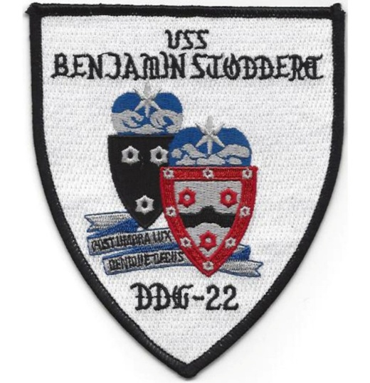
USS Benjamin Stoddert DDG22/
USS Jupiter AVS8 Association
SITREp
Spring Newsletter (March, April, May 2026)
Reunion Omaha, September 22nd-27th
Embassy Suites Downtown Old Market
555 South 10th Street, Omaha, NE 68102
Don’t Miss Out on 50/50 Drawing

Help support the Association: Remember that the 50/50 drawing is always open to everyone. You do not have to be in attendance at the reunion to be a winner. We have had several non-attendees win in the past and there could be more in the future. Any winners not in attendance will have a check sent to them. Ticket sales will continue up to a few minutes before the drawing after the buffet dinner on Saturday. You do not have to be a paid up member of the Benjamin Stoddert Association to win—so anyone can win!
To get your chances entered, post a check to our Treasurer (Carole Bryan, 429 S Roselle Road, Roselle, IL 60172. $10 buys 12 chances. If you are registering for the reunion, include the 50/50 drawing in your total. If you want to enclose return address labels, the reunion committee will stick them on for you.
Day one tour (Thursday) Board the bus at 09:30, and depart the hotel at 09:45.
First stop is the Joslyn Art Museum.
When George Joslyn died in 1916, he was the richest man in Nebraska (that honor now goes to Warren Buffett) His widow, Sarah, founded and funded the non-profit Society of Liberal Arts, and wanted a memorial building dedicated to his memory that would reflect their love for the Arts. Originally designed as a concert hall, as befit their love of music, art galleries were added at the suggestion of Omaha fine arts groups. Planning started in 1920 and construction started in 1928. In 1931 the center opened and has had several expansions, the latest completed in 2024, almost 100 years after construction first began.
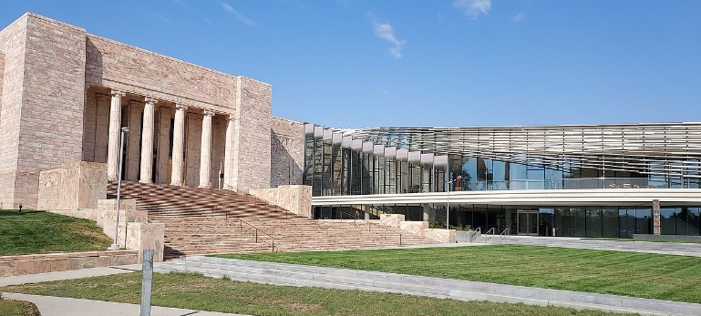
“At Sarah Joslyn's request, the opening was commemorated with no fanfare. There was no opening speeches or ribbon cutting, and Sarah Joslyn herself watched from the street. Nevertheless, the opening was attended by an estimated 25-30,000 people.” (Wikipedia)

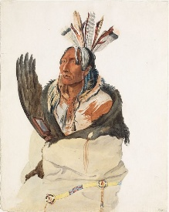
Today, the Joslyn is home to more than 12,000 objects of art, including paintings of the European Masters, early American works, Greek pottery, sculptures, contemporary pieces and numerous artifacts. The one hour allotted for our tour will afford a mere taste of this vast collection. Art lovers will want to revisit on their own.
https://joslyn.org for more information.
(Mary Cassatt’s Woman Reading)
Housed in the former Union Pacific Omaha Station is the *Durham Museum, our second stop on the Thursday tour. The museum offers permanent exhibits like these:
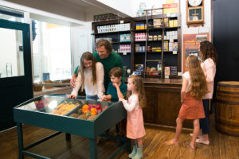
Buffett Grocery Store: This exhibit features a replica store front of the original Buffett Grocery Store that opened in 1915 in Omaha’s Dundee neighborhood.
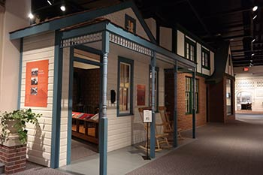
Baright Home and Family Gallery: Before the land became dotted with wooden and brick structures, it was a rolling prairie inhabited by the Omaha Indian tribe. Experience the history of this fascinating culture by stepping into a rawhide tepee or by sitting by the fire of a replica earth lodge. From the mid-1880s to 1915, “Worker’s Cottages” were constructed in most sections of Omaha as housing for blue-collar families. Many of these unique one story and one-and-a-half story homes still exist today. Go back nearly 100 years and peek into the attic, parlor, kitchen and bedroom of the museum’s reproduced “Worker’s Cottage.” Living in an English Tudor-Revival home in the Dundee district during the 1940s meant prosperity. Items that reflect period technology and the comforts of home are featured in this exhibit.
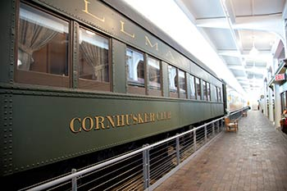
Model trains, actual streetcars (you can have seat in one), a coin and currency collection, and much more await us in the Durham. Stroll through train cars from the 1940s and 50s including a Pullman car, lounge car and caboose. Get up close to a steam engine and experience the history of railroad travel.
There will be two special exhibits this fall:
NEBRASKALAND: CELEBRATING 100 YEARS OUTDOORS. Outdoor Nebraska, renamed Nebraskaland in 1964 in the first issue shared the foundation of its mission as a “Love for the outdoors, respect for rights of others, understanding and appreciation for the law and the desire to build up the future.”
IN SEARCH OF THE SIGNERS: Documents and manuscripts pertaining to signers of the Declaration of Independence.
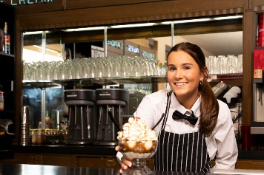
We don’t want to miss the old-time Soda Fountain where we can eat lunch from a menu of salads, mac & cheese, hotdogs, pulled pork and other sandwiches, and a Nebraska favorite, chili and cinnamon rolls.
*The Durham Museum replaces Lauritzen Gardens on the tour as the L.G. is unavailable on that day. It will be open on the weekend, for those who want to go on their own.
At about 13:15 we will reboard the bus and go to Omaha’s Memorial Park. Memorial Park is a 67-acre city park honoring veterans of World War II, Korea, and Vietnam, featuring lush green spaces and monuments. This will be the best site to get a group photo of everyone.
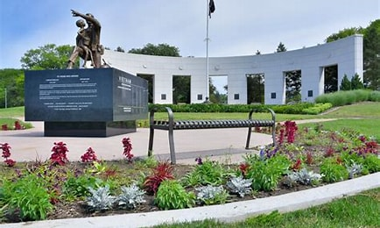
The Boys Town tour will take us through, what is, perhaps, Omaha’s most famous site: the home for orphaned boys established by Father Edward Flanagan in 1917 and made famous in the 1938 movie, Boys Town, starring Spencer Tracy and Mickey Rooney. In 1921, Father Flanagan relocated the orphanage to Overlook Farm, its present site.
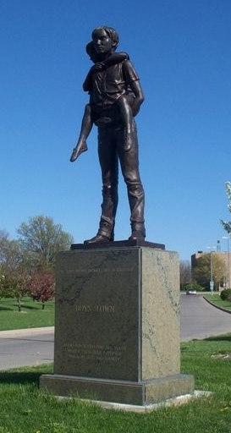
Christa, from Boys Town, will guide us for the full tour. This will be about 2 1/2 hours (1415-1645). She will hop on our bus and guide us through their campus showcasing Father Flanagan's home, The Chapel, Hall of History, and more! The Gift Shop will be a popular spot at the conclusion of our tour.
Boys Town now has 9 sites in 7 states.
The “He Ain’t Heavy, He’s My Brother”
The Omaha City Tour has been scratched from the original itinerary to allow for the full tour at Boys Town.
Other Omaha attractions not on the tour, but well worth checking out, include:
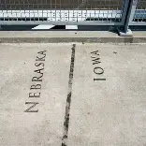
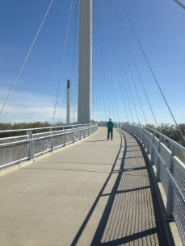
The Bob Kerrey bridge: a 3,000 foot long pedestrian bridge from Omaha to Council Bluffs, Iowa. At its midpoint, you can hop from one state to another. It is a little over a mile walk over and back.
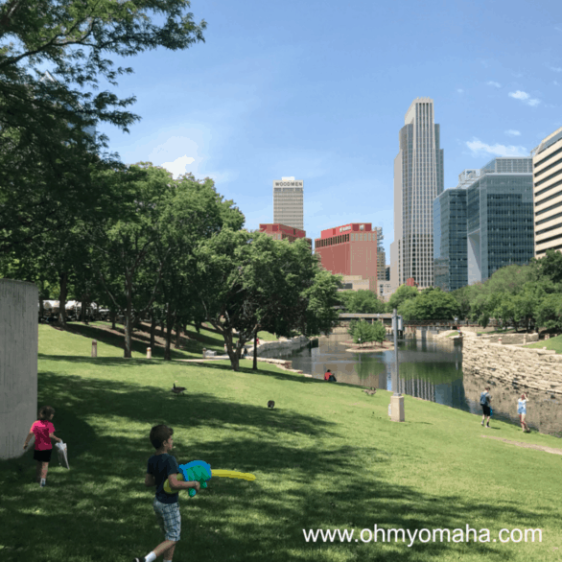
Gene Leahy Mall is Omaha’s version to Central Park Mall (in fact, that was its original name). The green space is in Downtown Omaha from 13th to Eighth streets between Douglas and Farnam streets. It has a sculpture garden, a promenade, cascade fountain (perfect for wading, which is permitted), a dog park, playground and more.
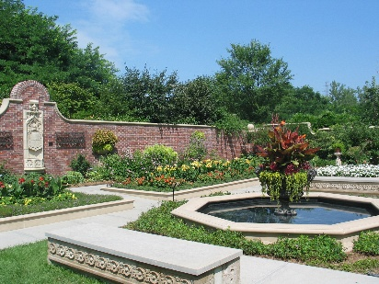
Lauritzen Gardens & Tram Ride: “The tram drives past the Hitchcock-Kountze Victorian Garden, English perennial border, Garden in the Glen, Arboretum and Oberman Bird Sanctuary, model railroad garden (lower tracks are most visible), Robert H. Storz Family Rose Garden, color burst bed, horticulture complex, herb garden, and Japanese park. There are 2, 10-minute stops at the conservation discovery garden/Founders’ Garden and the rose garden, where guests may deboard and explore the surrounding areas.
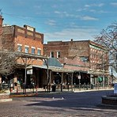
Omaha’s Old Market: Literally across the street from our hotel (Embassy Suites Downtown), is this historic area full of restaurants, upscale shops, and art galleries. Brick streets, horse-drawn carriages and covered sidewalks, street performers and vendors positively ooze charm in the daytime and give a vibrant vibe after the sun goes down.
Across the River in Council Bluff, Iowa, there are casinos, for those who like to gamble, plus a couple worthwhile attractions.
The Union Pacific Museum: The museum is housed in a historic Carnegie Library building in Council Bluffs, Iowa.
Explore railroad history and an extensive compilation of items from 150 years of our nation's western history, including artifacts, photographs, documents and equipment.
Just a short walk from the UPRR Museum, is the Squirrel Cage Jail. The Pottawattamie County Jail was the highest of high tech of the day. A 90,000-pound, three-story cell block that could be turned by one man with a hand crank. The jailer didn't walk to the cells; he brought them to him. Efficient and cost effective--an entire jail could be controlled with just one man. The Jail was built in 1885 and was in continuous use until 1969. It was acquired by the Council Bluffs Park Board in 1971 for preservation, and was named to the National Register of Historic Places in 1972 by the United States Government. The Historical Society led an effort in 1977 to save the jail, and today they own and operate the museum.
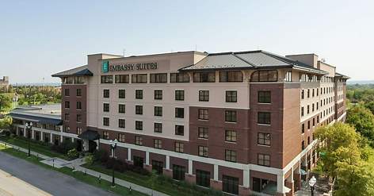
Our hotel: Omaha Embassy Suites Downtown/Old Market. 555 South 10th Street, Omaha, NE 68102 402-346-9000
We have a block of 25 rooms at this hotel, with the option to expand the block if needed. The reunion room rate of $149, plus tax, has been extended for two days before, and two days after our reunion dates of September 23rd—27th. Attendees are responsible for making their own reservations by calling 1-800-362-2779, and ask for the Benjamin Stoddert Reunion rate. We have had some issues with those who want to check in on the 22nd as being told the block is sold out—it isn’t. I think this has been corrected, but if you run into this, drop me an email (aghansen52@gmail.com) or text or call me at 308-627-6901 and leave a message. I’ll respond as soon as I can.
Made to order breakfast and an evening reception everyday are free with your room, and the hotel offers every amenity.
Parking is $26 per day for self-parking, and $37 for valet.
A short history of the Benjamin Stoddert reunions
The Benjamin Stoddert reunions started in 2005—well, that was when the first reunion was held. It actually started earlier, in 2004, when a retired ETC reached out to a specialized company, Military Reunions to Remember (MRTR). Herm Chambers contacted MRTR about setting up reunions for the Stoddert. MRTR somehow got the word out to past crew members of the Stoddert with a survey (if I remember correctly) asking if there was any interest in holding a reunion. I believe I got a letter in the mail and responded via email.
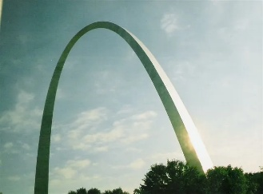
MRTR took over and I was soon notified of a reunion in St. Louis, Missouri to be held in the fall. MRTR had a formula that they used for all reunions and recommended strongly that we not deviate. Included was the idea that the reunion would culminate in a banquet meal, a plated dinner. The dress code for the banquet was business formal (suit and tie for the men, dresses for the ladies). MRTR picked the reunion sites ahead of time and then pitched them at the business meeting.
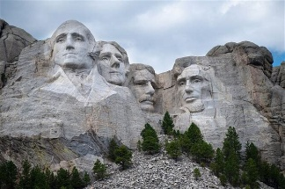
This system worked until the 5th reunion. Because (I believe) we voted to go to Rapid City, South Dakota for the 5th reunion, rather than whatever site was offered by MRTR, we did not get our usual attention and service from Terry McManuels. Instead, we had a lady from MRTR who clearly did not have a grasp on her assignment. We were sufficiently underserved and disappointed that we decided that we would handle setting up the future reunions and cut our ties to MRTR.
At our business meeting in Rapid City, we voted to fire MRTR and elected Herm Chambers as our Association President and Lou Turilli VP. Together, they planned the San Diego reunion. From that point on, the reunions have been set up by Stoddert Sailors, Ron Zorn and John Dishaw being responsible for most of them.
We also decided that since we were in the “Pineapple Navy” that Aloha shirts were more appropriate for our banquet. Also that buffet style dinners, rather than a served plated meal, made more sense, and would help make the reunions more affordable.
At the business meeting in Omaha we will select our 2028 reunion city, the 2027, the Charlston site having been selected last year at the Oklahoma City business meeting. If you want to promote your city, come to the reunion, attend the business meeting and make your pitch. You never know—we might be coming to your hometown. The 2026 reunion in Omaha will be our 21st reunion and we are working to make it one “to be rembembered.”
This newsletter is named SITREP (Situation Report) at the suggestion of Herm Chambers. RIP Chief.
Memories were made at all of these past reunions
2005 First USS Benjamin Stoddert reunion held in St. Louis, MO
2006 Philadelphia, Pennsylvania (King of Prussia)
2007 Concord, California
2008 Washington, DC
2009 Rapid City, South Dakota (Rapid City was the last one by MRTR (Military Reunions to remember)
2010 San Diego, California
2011 Jacksonville, Florida
2012 Albuquerque, New Mexico
2013 Seattle, Washington
2014 Honolulu, Hawaii
2015 Nashville, Tennessee
2016 Jacksonville, Florida
2017 Tucson, Arizona
2018 Providence, Rhode Island
2019 Reno, Nevada
2020 Nowheresville, No Where (Covid Cancelled)
2021 San Antonio, Texas
2022 Savannah, Georgia
2023 Sacramento, California
2024 Honolulu, Hawaii
2025 Oklahoma City, Oklahoma
Future Reunions
2026 Omaha, Nebraska
2027 Charlston, South Carolina
2028 TBD
2029 TBD
2030 TBD (San Diego--our Silver Anniversary Reunion?)
2031 TBD
2032 TBD
2033 TBD
2034 Honolulu, Hawaii (70th Anniversary of Commissioning)
IN MEMORIAM
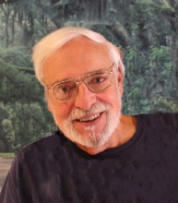
Louis (Lou) Turilli, Past President and Vice-President of the Benjamin Stoddert Association died suddenly on June 7th, 2025. Lou was a proud Navy veteran who served on the USS Benjamin Stoddert DDG22 from 1968-69. He was instrumental in founding the USS Benjamin Stoddert Reunion Association and for the last twenty years attended annual reunions with shipmates from all years the ship was commissioned. He will be sorely missed at future reunions.
LOOKING AHEAD
The next issue of SITREP will give a closer look at the Friday tour and what to expect at SAC Museum and in Lincoln, Nebraska.

Registration Form – Omaha, NE Reunion
Embassy Suite by Hilton Omaha--Downtown/Old Market
555 South 10th Street, Omaha, NE 68102
Tuesday, September 22nd to Sunday, September 27th, 2026
Room Rate: $149+tax
Reservation Phone # 1-800-362-2779 (Ask for the Benjamin Stoddert Reunion Group)
REGISTRATION CUT-OFF DATE: Wednesday, September 2, 2026

Please note that you must be a member, the spouse or descendent of a member, or the guest of a member to attend our reunion.

Remember: You are responsible for your own transportation to and from the airport, and for your own hotel reservation. Parking: Overnight parking is available at the hotel for $23 self-park, $29 for valet parking service.

QUESTIONS?? Call Art Hansen at 308-627-6901 or Carole Bryan at 630-825-4398

*Name: _____________________________ Is this your first reunion? _______

Home Address: _________________________________ Apt/Unit #: _________

City: _____________________________ State: _______ Zip: _______________

Home Phone: ______________________ Cell Phone: _____________________

Email Address: _____________________________________________________

*Department/Division/ _____________ *Years aboard: From ______ to _______

Spouse’s name: ______________________________

Guest’s name: ________________________________

Emergency Contact Name: ___________________________ Phone: _______________

(*The above information is required for your name tags.)

Member name: __________________ Page 2
Registration Form – Omaha, NE Reunion
Embassy Suite by Hilton Omaha--Downtown/Old Market
555 South 10th Street, Omaha, NE 68102
Tuesday, September 22nd to Sunday, September 27th, 2026

2027 Membership Dues: $30 x (_______) $_______

50/50 Tickets $10 per sheet (12 tickets) x # of sheets $10 x (_______) $_______

Day 1 -- Tuesday, September 22nd Registration Fee: $25 x (_______) $_______

Day 2 – Wednesday, September 23rd
Hospitality Suite Open for Registration & social 0800—2100

Day 3 – Thursday, September 24th Omaha Tour $70 x (_______) $_______

Day 4 – Friday, September 25th SAC + Lincoln $70 x (_______) $_______

Day 5 – Saturday, September 26th Banquet $70 x (_______) $_______
Social Hour and pictures at 1730 hours
Buffet Dinner at 1830 Total: $__________

Day 6 – Sunday, September 27th Depart for home

Payment: Option 1: Complete this form (both sides) and mail with check or money order payable to: USS Benjamin Stoddert Association
Carole Bryan
429 Roselle Road
Rosellle, IL 60172

Option 2: Zelle payment to carolebryanddg22 and email a photo/scanning of the completed registration form to: carolebryanddg22@msn.com
Or Venmo @ Carole-Bryan-8
For issues with Zelle or Venmo, please call Carole at 630-825-4398.

