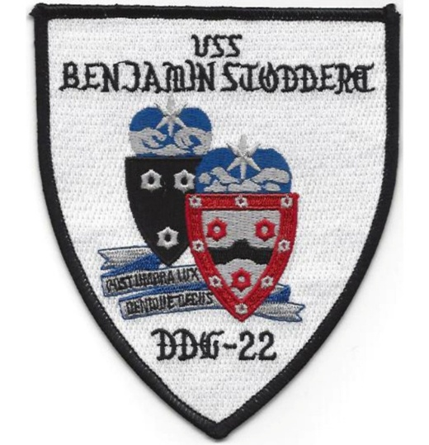
USS Benjamin Stoddert DDG22/
USS Jupiter AVS8 Association
SITREp
Summer Newsletter (June, July, August 2026)
Reunion Omaha, September 22nd-27th
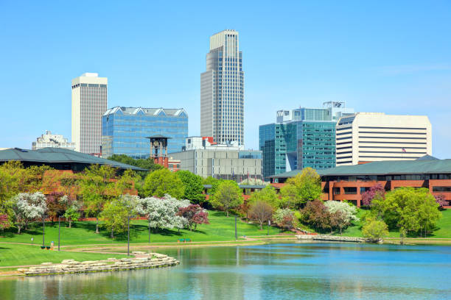
Embassy Suites Downtown Old Market
555 South 10th Street, Omaha, NE 68102
Cutoff date for the hotel reservations (with the Stoddert Reunion Discount) is August 22nd: Call 1-800-362-2279
We have a block of 25 rooms at this hotel, with the option to expand the block if needed. The reunion room rate of $149, plus tax, has been extended for two days before, and two days after our reunion dates of September 22rd—27th. Attendees are responsible for making their own reservations by calling 1-800-362-2779, and asking for the Benjamin Stoddert Reunion rate. Any issues with getting reservations or the room rate, drop me an email (aghansen52@gmail.com) or text or call me at 308-627-6901 and leave a message. I’ll respond as soon as I can. Breakfast is included in the room rate.
The time to register is NOW
Cutoff date for registration for the Reunion banquet and tours is Sept. 2nd
Tuesday, September 22nd, the early arrivals will check into the Embassy Suites and set up to register guests for the 2026 Stoddert Reunion. The Hospitality Suite will be open from 1600-1900 for early registration.
Wednesday, September 23rd, registration will be set up in the hotel lobby, 0800—2100. The Hospitality Suite will be open for refreshments and conversation. A business meeting will be held around 2000, depending on how many of the registered guests are available. A business meeting is scheduled for Saturday morning, if needed.
Omaha tour (Thursday) $70
- Joslyn Art Museum
- Durham Museum (*lunch at the Olde Time Soda Fountain) *Lunches can be ordered in advance—payment will be due the day of the tour. Owing to the cancellation of the Lauritzen Gardens tour—our intended lunch site, the Durham Museum is in its place. The Soda Fountain menu will be provided in this newsletter, and a link/order form where you can order your meal in advance. Advance orders due in by Sept. 7th.
- Omaha Memorial Park
- Boy’s Town
SAC Museum/Lincoln tour (Friday) $70
- SAC and Aerospace Museum
- Lunch in Lincoln’s Hay Market
- Nebraska State Capital tour
- Lincoln’s Sunken Gardens
- Nebraska Vietnam Veterans Memorial (Papillion)
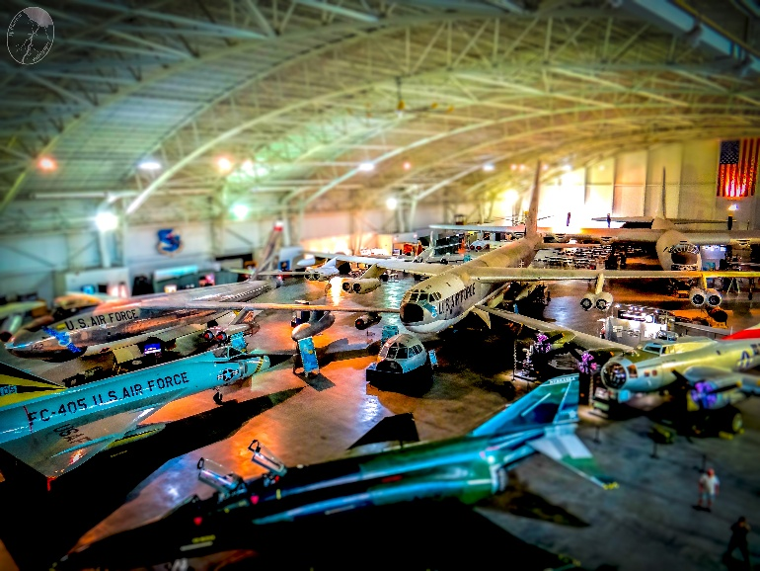The SAC inside and outside displays will ignite your memories and fire your imagination.
The SAC Museum was created as a center for housing the aircraft and artifacts used by the Strategic Air Command during the Cold War. Carefully restored airplanes and rockets are displayed in the massive, award-winning structure as well as outdoor displays.
“The museum remains a significant historical resource while also using its collection to ignite the imagination of tomorrow’s scientists and explorers. Specializing in science and space exploration, technological innovation and a genuine commitment to sharing and preserving our nation’s history, we’re uniting our past and future to secure our spot as the Midwest’s premier museum and science center.” SAC Museum website. SAC Aerospace Museum webpage.
The Museum has a snack bar where you can get coffee, pastries, or even lunch. But you’ll probably want to wait for lunch until our next stop: Lincoln’s Haymarket District.
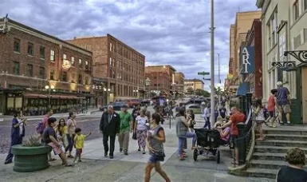
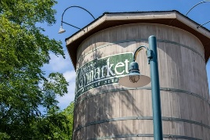
The Haymarket District is a revitalized shopping and dining area in Lincoln, just a few minutes’ walk from the State Capitol Building, the University of Nebraska and downtown Lincoln. It gets its name from the days when this district was the primary site for buying and selling agricultural products, livestock, and even hay, in the late 19th and early 20th centuries. Today it is home to shops and restaurants that are favorite stops for residents and visitors alike.
This will our lunch stop. We’ll have 90 minutes to eat and relax before continuing on for the Capital Building tour. There are many restaurants with various ethnic and American cuisine.
- Kasumi Sushi
- Brewsky’s Haymarket Restaurant
- El Potrero Mexican Restaurant
- The Oven Indian Restaurant
- Lazlo’s Brewery and Grill
- Ledbelly (Bar and Grill)
- Buzzard Billy’s (Cajun)
- The Mill Coffee & Tea (and food)
Unfortunately, many of the eating establishments are dinner only affairs and will not be open over the lunch hour.
Shopping time will be limited, but you might want to save a few minutes for Burlington Antiques, Licorice International, or one of the other fine shops located here. Then it’s on to the Capitol.
The Nebraska State Capitol Building tour will take you through the building that was once listed as one of the Seven Wonders of the Modern World. Completed in 1932 in four phases, with a pay-as-you-go schedule, at a cost of $9.8 million, this stately tower was designed to evoke the imagery of another Nebraska landmark, Chimney Rock in the western panhandle. Chimney Rock was a welcome sight to wagon trains crossing the endless, treeless prairie.
Inside, the beautiful sculptures and mosaics tell the story of the state. Constructed of Indianna limestone and Italian marble, the 400 feet tall Art Deco structure has stood as an emblem of Nebraskan pioneer spirit and industrious ingenuity.
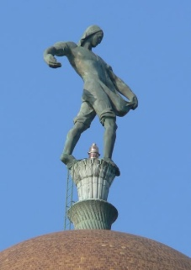
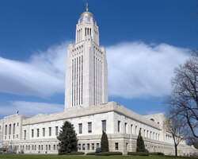
Inside are murals and sculptures that add to the story of Nebraska and highlight the ideals of mankind, depicting the ideals of International Law, Freedom, Universal Peace, and Self-determination. Additional murals show the heroic work of first responders and medical personnel, and the scourge of famine and poverty.
The “Sower” is 19’ tall and weighs nearly 9.5 tons (19,000 lbs) standing atop dome.
An extensive exterior restoration project was completed in recent years, so it is not likely that we will have to deal with construction and scaffolding for our tour. Although, there may be some interior work still in progress.
Sunken Gardens: The only Nebraska garden to be listed in the “300 Best Gardens to Visit in the United States and Canada” by National Geographic’s "Guide to Public Gardens", this enchanting place is important to many. Formerly a neighborhood dumpsite, these 1.5 acres were first developed in 1930, and were transformed into an iconic feature of Lincoln. (Lincoln Parks and Recreation website)
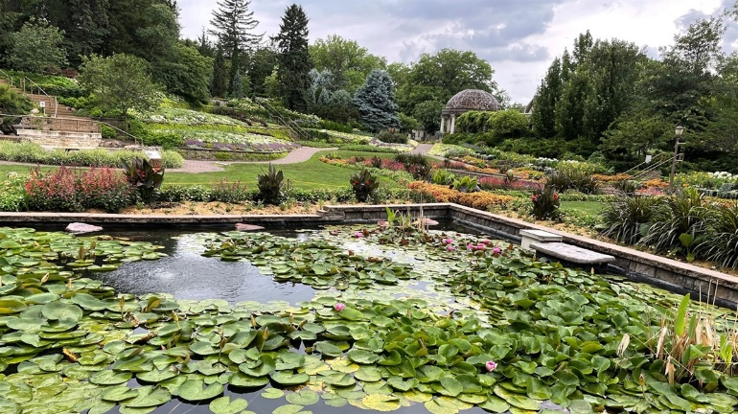
On the way back to our hotel in Omaha, we will have a stop at the Nebraska Vietnam Veterans Memorial, in Papillion.
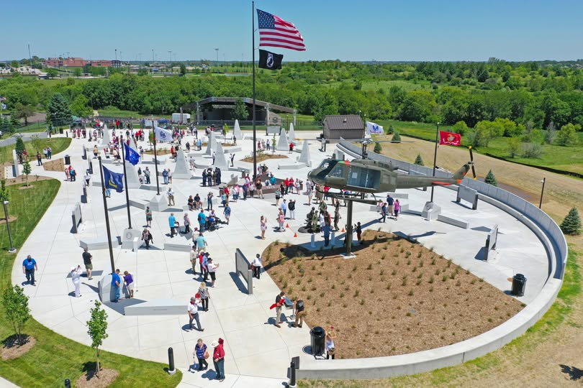
The Nebraska Vietnam Veterans Memorial is dedicated to memorializing those Nebraskans who lost their lives while in service to their country during the Vietnam War and to tell their story so that they continue to live in our hearts. The unique stories of our Vietnam Veterans offer thought-provoking and heartfelt lessons for our future. While the site is dedicated to those Nebraskans that lost their lives while serving in Vietnam, our site is for ALL Vietnam Veterans. (NVVM website)
Don’t Miss Out on 50/50 Drawing
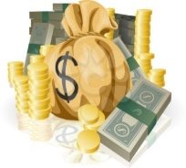
Help support the Association: Remember that the 50/50 drawing is always open to everyone. You do not have to be in attendance at the reunion to be a winner. We have had several non-attendees win in the past and there could be more in the future. Any winners not in attendance will have a check sent to them. Ticket sales will continue up to a few minutes before the drawing, which will be after the buffet dinner on Saturday. You do not have to be a paid-up member of the Benjamin Stoddert Association to win—so anyone can win!
To get your chances entered, post a check to our Treasurer (Carole Bryan, 429 S Roselle Road, Roselle, IL 60172. $10 buys 12 chances. If you are registering for the reunion, include the 50/50 drawing in your total. You will receive your tickets in your registration packet when you register at the hotel.
Soda Fountain Group/Tour Specials
Please see pricing below for pre-ordered meals and ice cream sundaes available during museum business hours.
*Boxed Lunch Meal - $12
Meal includes choice of cold Deli Sandwich, chips, and a bottled water or can of Diet Coke/Coke/Sprite.
1) Ham and cheddar on Wheat bread (unless specified otherwise)
2) Turkey and provolone on Wheat bread (unless specified otherwise)
*Exception may be made for GF needs (salad option). Tomato, Onion, Lettuce and Condiments will be available.
*Children Boxed Lunch Meal - $7
Meal includes choice of below, Chips or Applesauce, and a bottled water or can of Coke/Diet Coke/Sprite.
1) PB&J Uncrustable or,
2) Mac & Cheese
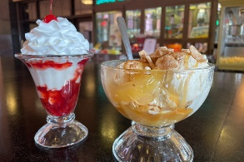
1 Scoop Sundae - $3.50
One generous scoop of vanilla ice cream with your choice of syrup; (Chocolate, Caramel, Strawberry, Butterscotch, Marshmallow)
topped with whipped topping, peanuts, and a maraschino cherry (unless specified otherwise).
1 Scoop Ice Cream with syrup topping - $3
Vanilla Ice Cream with choice of syrup (Chocolate, Caramel, Strawberry, Butterscotch, Marshmallow)
*Gratuity is not included, but is appreciated.
**Prices are tax included
Advanced ordering was not known until recently. We are working out how to collect for those who want a box lunch and Sundaes.
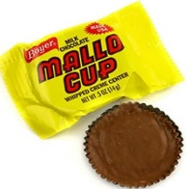
Box lunches are for your convenience, to permit more time for exploring the museum. If you want to wait and order at the counter, that is your prerogative. A full menu is available on-line at Durham Museum.com. Additionally, the Durham is located just a few blocks from the Old Market district, which is loaded with restaurants—everything from Jimmy John’s to Spaghetti Works to $$$ chop/steak houses.
The old-fashioned Candy Shop will entice any sweet tooth! They offer an expansive variety of nostalgic, hard-to-find candies.

Chick O Sticks, Clark Bars, Slo-Pokes and Mary Janes, Mallo Cups (my favorite) and Bit-o-Honey! Probably even have Black Jack gum.
Plus, who can pass on fresh popcorn?

Registration Form – Omaha, NE Reunion
Embassy Suite by Hilton Omaha--Downtown/Old Market
555 South 10th Street, Omaha, NE 68102
Tuesday, September 22nd to Sunday, September 27th, 2026
Room Rate: $149+tax
Reservation Phone # 1-800-362-2779 (Ask for the Benjamin Stoddert Reunion Group)
REGISTRATION CUT-OFF DATE: Wednesday, September 2, 2026

Please note that you must be a member, the spouse or descendent of a member, or the guest of a member to attend our reunion.

Remember: You are responsible for your own transportation to and from the airport, and for your own hotel reservation. Parking: Overnight parking is available at the hotel for $23 self-park, $29 for valet parking service.

QUESTIONS?? Call Art Hansen at 308-627-6901 or Carole Bryan at 630-825-4398

*Name: _____________________________ Is this your first reunion? _______

Home Address: _________________________________ Apt/Unit #: _________

*City: _____________________________ *State: _______ Zip: _______________

Home Phone: ______________________ Cell Phone: _____________________

Email Address: _____________________________________________________

*Department/Division/ _____________ *Years aboard: From ______ to _______

Spouse’s name: ______________________________

Guest’s name: ________________________________

Emergency Contact Name: ___________________________ Phone: _______________

(*The above information is required for your name tags.)

Member name: __________________ Page 2
Registration Form – Omaha, NE Reunion
Embassy Suite by Hilton Omaha--Downtown/Old Market
555 South 10th Street, Omaha, NE 68102
Tuesday, September 22nd to Sunday, September 27th, 2026

2027 Membership Dues: $30 x (_______) $_______

50/50 Tickets $10 per sheet (12 tickets) x # of sheets $10 x (_______) $_______

Day 1 -- Tuesday, September 22nd Registration Fee: $25 x (_______) $_______

Day 2 – Wednesday, September 23rd
Hospitality Suite Open for Registration & social 0800—2100

Day 3 – Thursday, September 24th Omaha Tour $70 x (_______) $_______

Day 4 – Friday, September 25th SAC + Lincoln $70 x (_______) $_______
Boxed lunch (option #1 or #2) $12 x (_______) $_______
Child’s Lunch (option #1 or #20 $7 x (_______) $_______
One scoop sundae (syrup choice) $3 x (_______) $_______
(Chocolate, Caramel, Strawberry, Butterscotch, Marshmallow)
W/Extra toppings(whipped topping, peanuts, maraschino cherry)$3.50 x (_______) $_______

Day 5 – Saturday, September 26th Banquet $70 x (_______) $_______
Social Hour and pictures at 1730 hours
Buffet Dinner at 1830 Total: $__________

Day 6 – Sunday, September 27th Depart for home

Payment: Option 1: Complete this form (both sides) and mail with check or money order payable to: USS Benjamin Stoddert Association
Carole Bryan, 429 Roselle Road, Rosellle, IL 60172
Option 2: Zelle payment to carolebryanddg22 and email a photo/scanning of the completed registration form to: carolebryanddg22@msn.com
Or Venmo @ Carole-Bryan-8
For issues with Zelle or Venmo, please call Carole at 630-825-4398.

